Chapter 4: Searching and Analyzing Text
Ancillary Exercise 4.a: Using Filters
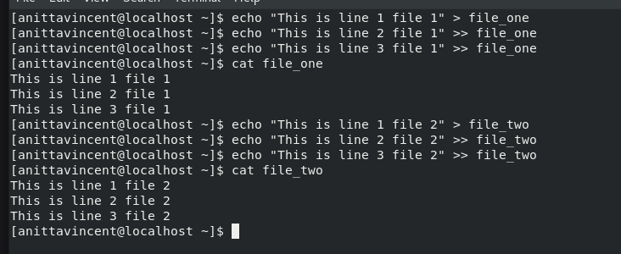
Tried redirecting the output of echo to file_one, and then append the contents to file_one using >>
Similar steps in file_two
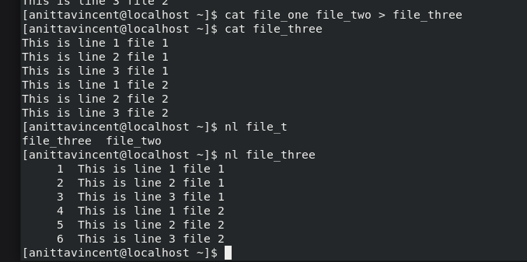
Concatenated file_one and file_two and redirected it to file_three. And displayed file_three
Displayed the line number in file_three using nl command.
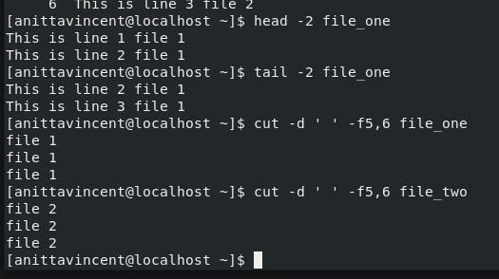
head -2 file_one : Shows the first 2 lines of file_one.
tail -2 file_one : Shows the last 2 lines of file_one.
cut -d ' ' -f5,6 file_one: Using space (' ') as the delimiter, extracts fields 5 and 6 from every line in file_one.
cut -d ' ' -f5,6 file_two: Using space as the delimiter, extracts fields 5 and 6 from each line of file_two.

The above command format the file as a paged document, then display it one screen at a time. The output of pr file_one | more is as below:
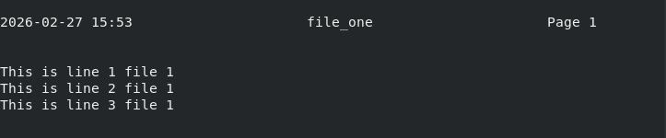
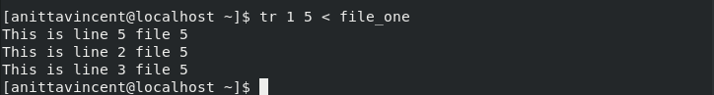
Using the tr command as above, every instance of 1 in file_1 has been substituted or translated into a 5
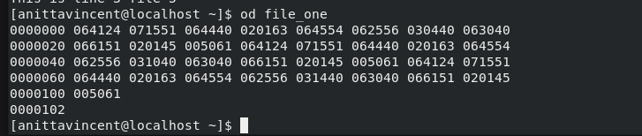
od command displays the file_one in octal format.
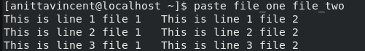
The paste command prints lines from two files as one line in a two column
format.
wc-l file_one prints the number of lines in file_one.
wc-w file_one prints the number of words in file_one.

wc-c file_one prints the number of characters in file_one.
Prints all the above 3 lines- the number of lines, words and characters
split -2 file_one file_four splits file_one into multiple smaller files, each containing 2 lines, and names them beginning with file_four.

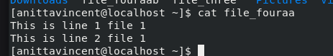

cat file_fouraa shows the contents of the first split file (file_fouraa). cat file_fourab shows the contents of the second split file (file_fourab).

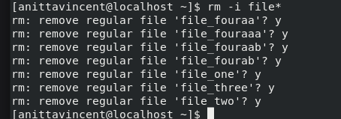
rm -i file* deletes all files whose names start with file, but asks you for confirmation (y/n) before removing each one.

4.b: Using Redirection
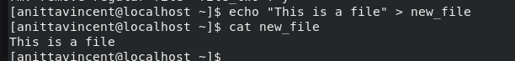
echo "This is a file" > new_file creates a file named new_file and writes the text “This is a file” into it, replacing any existing content.
cat new_file displays the contents of the file new_file on the screen.

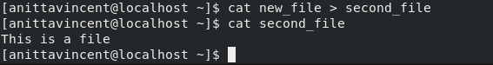
cat new_file > second_file copies the contents of new_file into a new file called second_file, replacing its contents if it already exists.
cat second_file displays the contents of second_file on the screen.

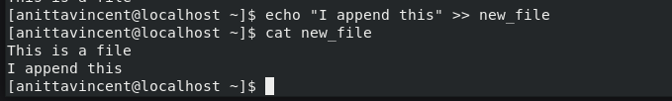
echo "I append this" >> new_file adds the text “I append this” to the end of new_file without overwriting the existing content.
cat new_file displays all the contents of new_file, including the newly appended text.

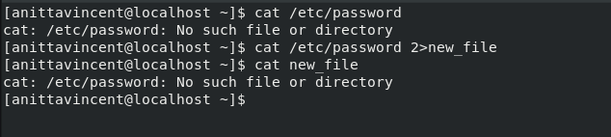
cat /etc/password attempts to display /etc/password but prints an error because the file does not exist.
cat /etc/password 2> new_file redirects only the error message (stderr) from the missing file into new_file.
cat new_file displays the contents of new_file, which contains the previous error message.

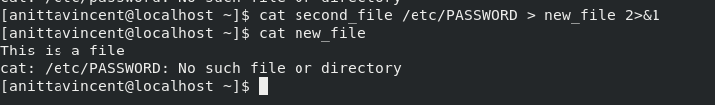
Concatenate the content of second_file and /etc/password and redirects it to new_file, redirects the std error also to where the std output goes(to new_file)
Use cat to display the content of new_file
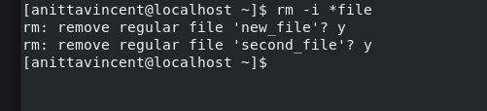
The command deletes every file whose name ends with file, but only after asking you to confirm

4.c: Using Regular Expressions
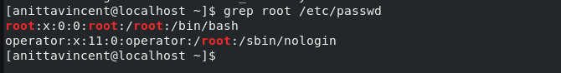
Looks for ‘root’ in the /etc/passwd file and prints it
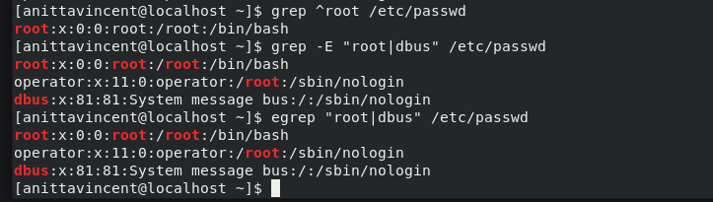
grep ^root /etc/passwd command finds only lines that start with “root”
grep -E “root|dbus” /etc/passwd matches a line containing root OR dbus anywhere in the line

----------------------------------------------------------------------------------------------------------------
Chapter 5: Examining the Boot Process
Exercise 5.a: Select an alternative boot device in your VM firmware
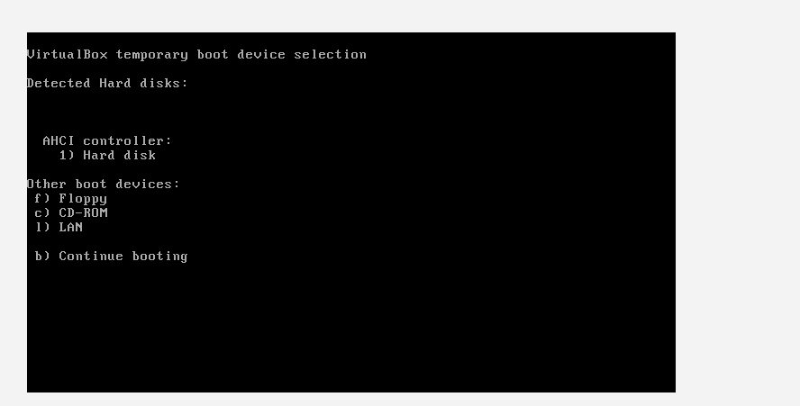
Before the Rocky Linux operating system starts, at the VirtualBox
splashscreen, press F12. At the menu, select to boot from the hard drive, a floppy disk, the CD-ROM drive, or the network. Type 1 to continue booting from the standard hard
drive installation.

Exercise 5.b: Boot Linux into single user mode
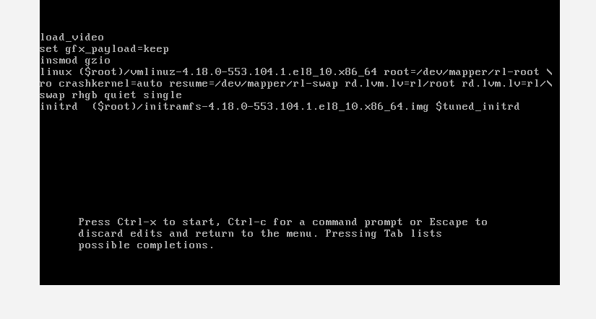
When the Rocky Linux GRUB menu appears, hit the E key. This takes you into edit mode for the GRUB configuration file. Look for the line that starts with linux. Scroll to the end of the line, and add single. Press Ctrl+X to boot the system with the new GRUB configuration

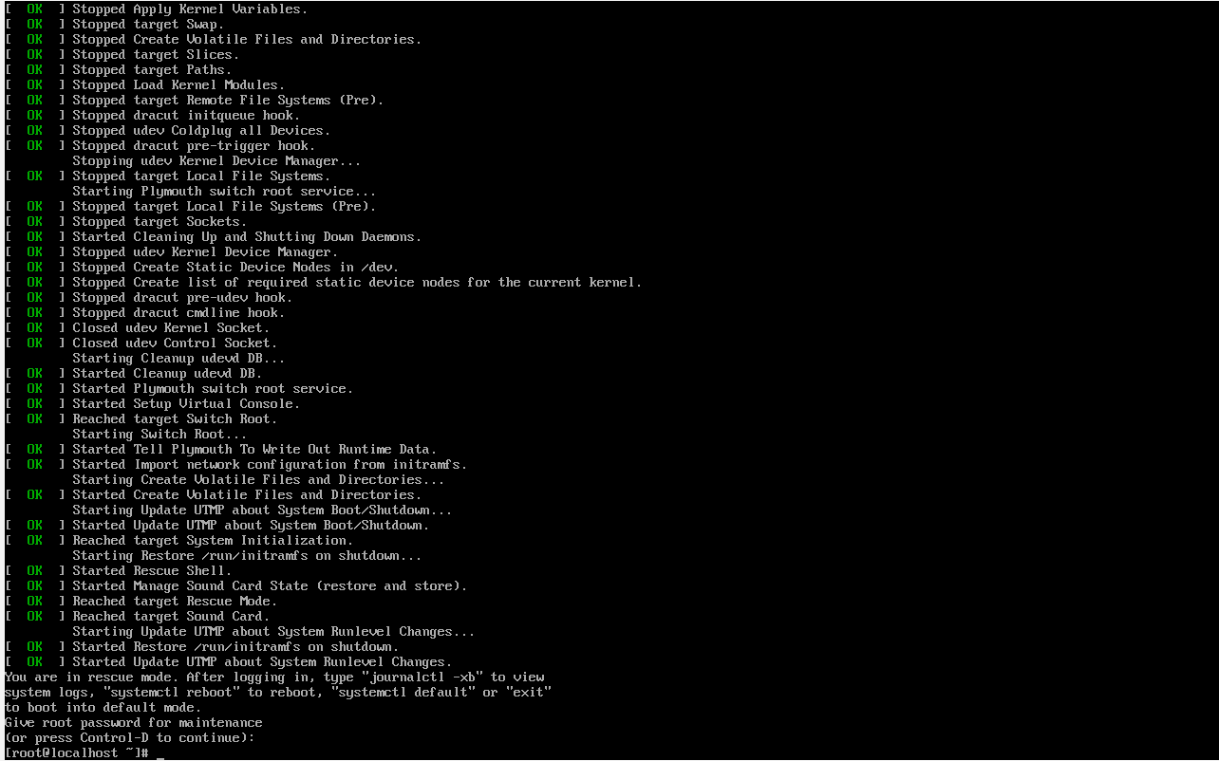
As the system boots, it will prompt you for the root user password, or to press
Ctrl+D to continue. Enter the root user password you set at installation time. Will now be in single user mode on the system as the root user account. No other terminals are active on the system.
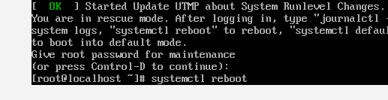
At the command prompt, type systemctl reboot to restart the system. The system will come up in normal graphical mode.
Exercise 5.c: View boot messages from the kernel
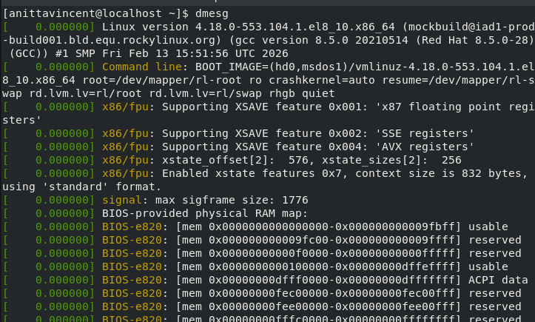
command dmesg lets see the entries in the kernel ring buffer to see what devices were detected at boot time, and how the kernel handled them.

Chapter 6 Maintaining System Startup and Services
Exercise 6.a: Determining the System Initialization Method
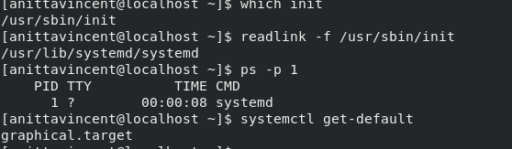
which init shows the full path of the init program that your system uses.
readlink -f /usr/sbin/init follows the symlink for /usr/sbin/init to reveal the real binary (usually systemd).
ps -p 1 displays details about process ID 1 — the main init/system manager.
Exercise 6.b: Employing systemctl
systemctl get-default shows the system’s default boot target (like graphical or multi-user).

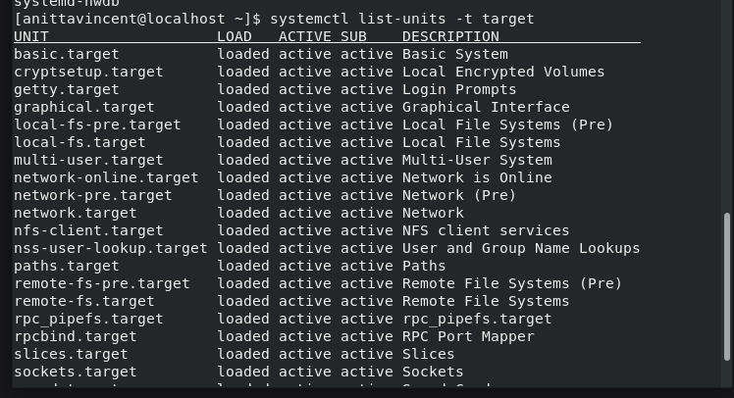
systemctl list-units -t target lists all active systemd target units, which represent system states like multi-user mode, graphical mode, networking, and boot milestones.

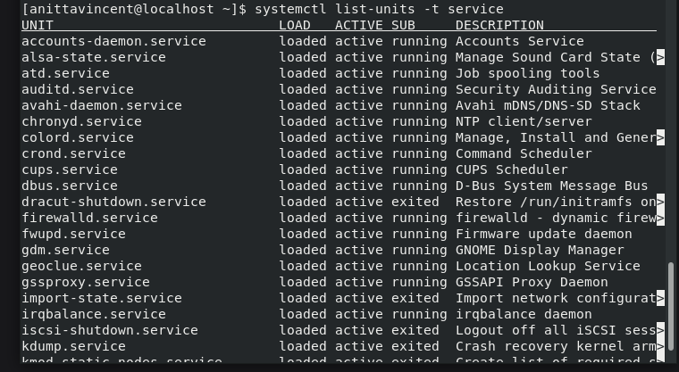
systemctl list-units -t service lists all active services managed by systemd, showing their load state, active state, and a short description.

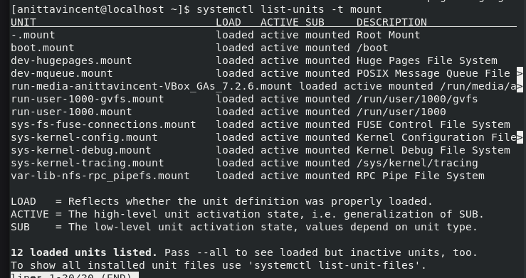
systemctl list-units -t mount shows all active mount units managed by systemd, listing currently mounted filesystems.

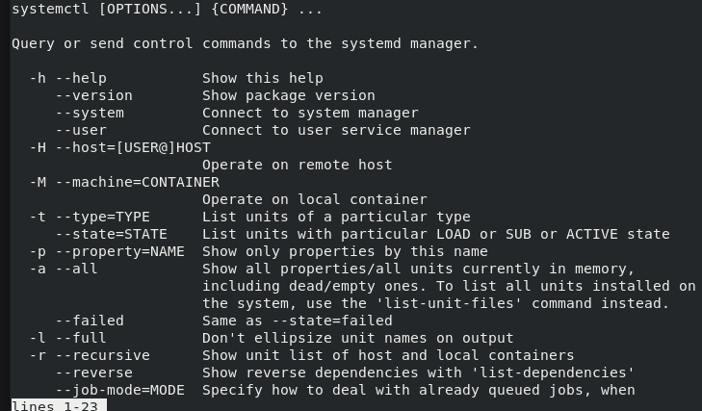
systemctl -help command will display a list of all available options, commands, and usage instructions for systemctl.
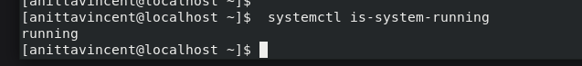
systemctl is-system-running checks the overall health state of the system and reports if it is running normally.

Powers off the system

Chapter 7: Configuring Network Connections

Exercise 7.a: Find the network information for your Linux system
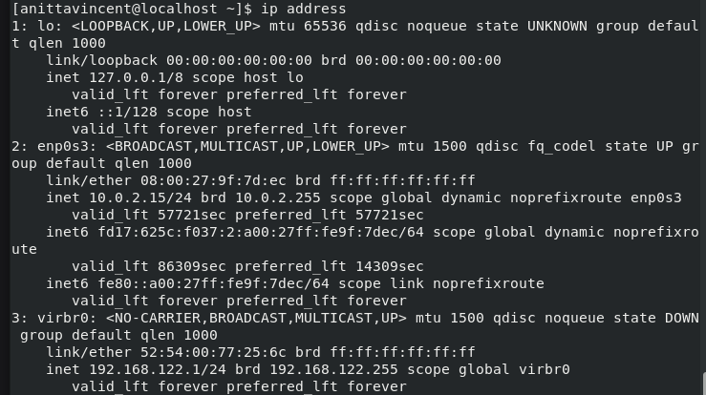
Output of command ip address to view the IP address assigned to the
workstation
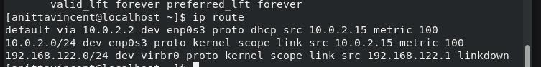
Output of command ip route to view the default routing information for your
workstation
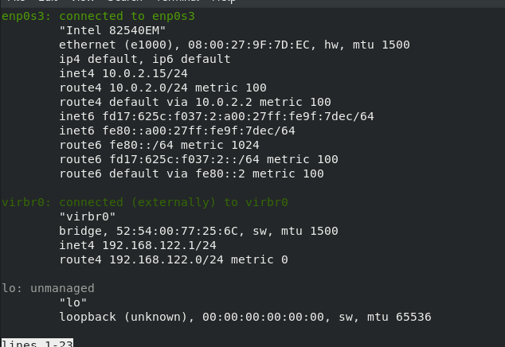
Output of the command nmcli to view the network information using the Network
Manager command line tool
Exercise 7.b Test network connectivity
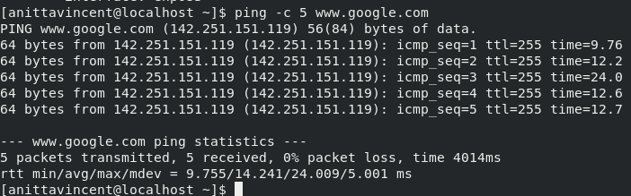
ping -c 5 www.google.com — Sends exactly 5 ICMP echo requests to www.google.com and prints replies.

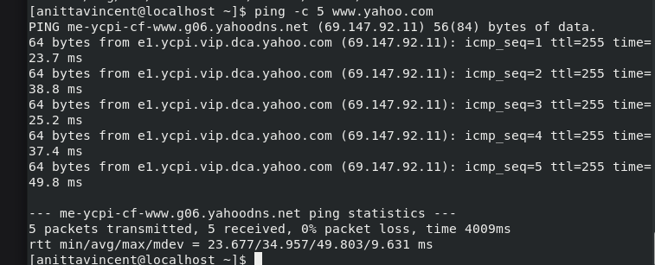
ping -c 5 www.yahoo.com — Sends exactly 5 ICMP echo requests to www.yahoo.com and prints replies.
Exercise 7.c: Find mail server for a specified domain
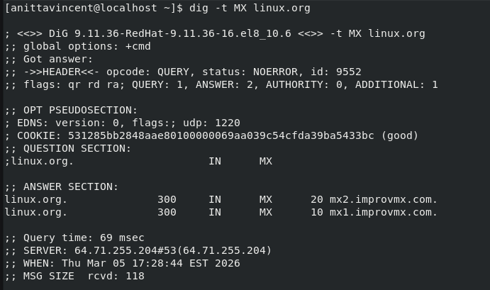
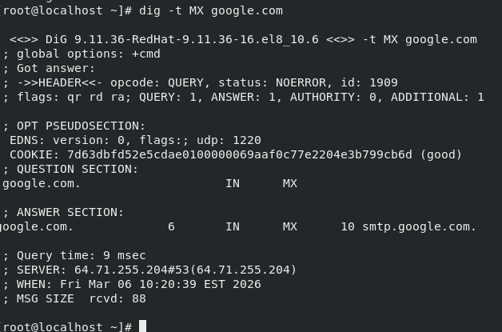
Queries DNS for the mail-exchange (MX) records of linux.org and google.com

